Blue Pink Multimedia System Final Project(BN01)

By:

Mellysa Verenna 2101655834

Jenifer Yolanda A 2101657921

Bela KristiantI 2101711122

*Main Page*

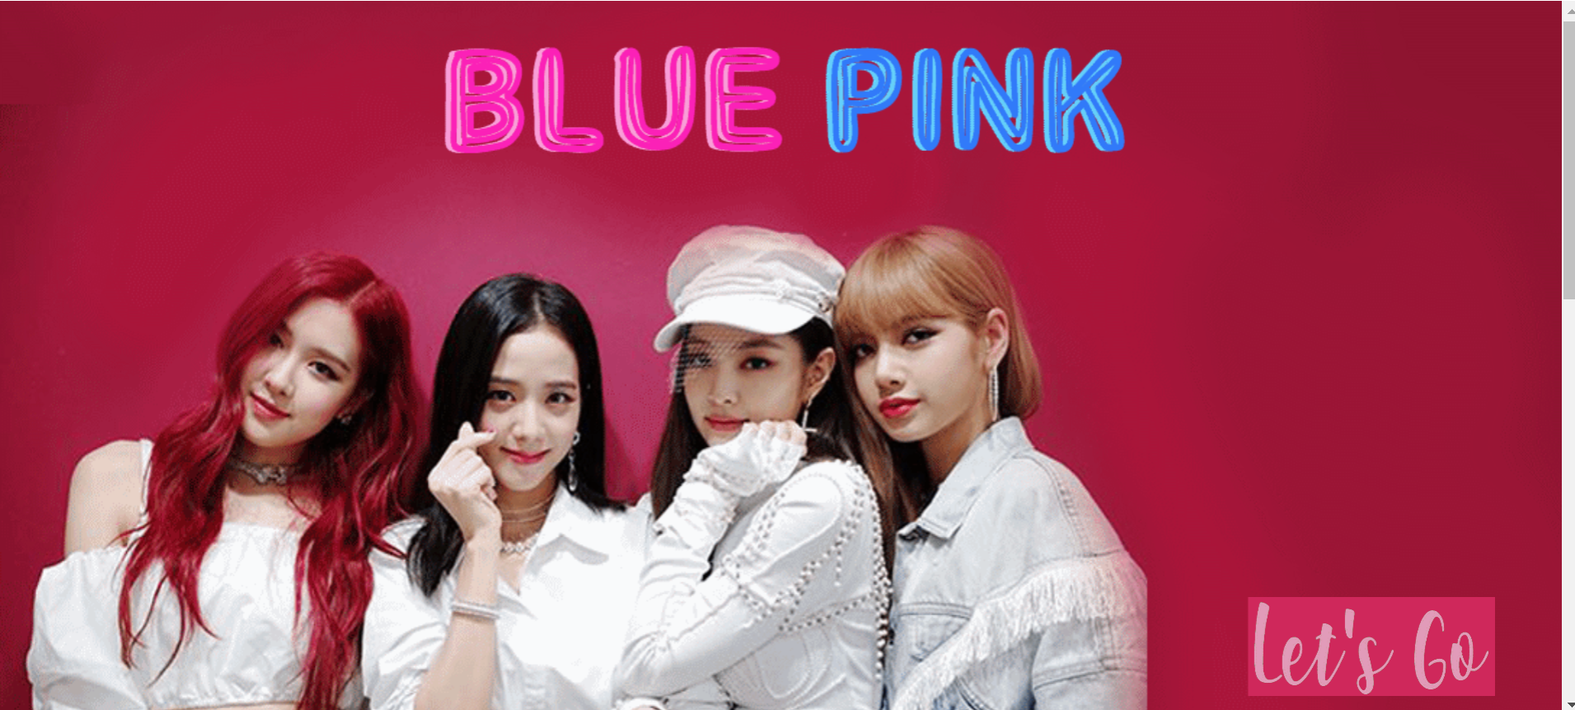

Scroll Down

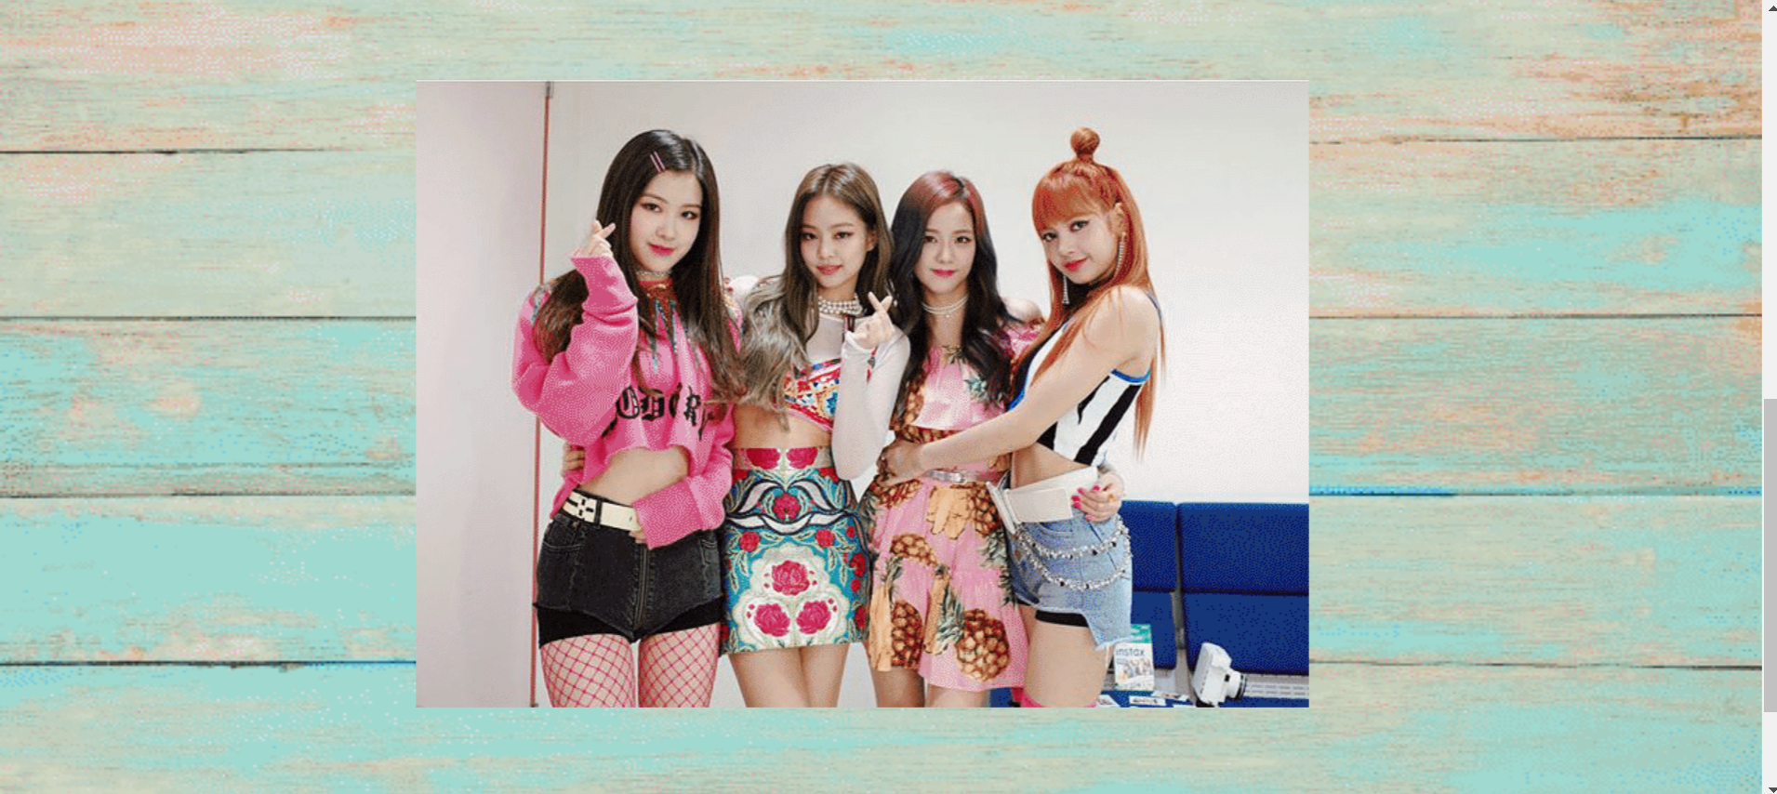

Scroll Up again and click the Lets Go button

*Home Page*

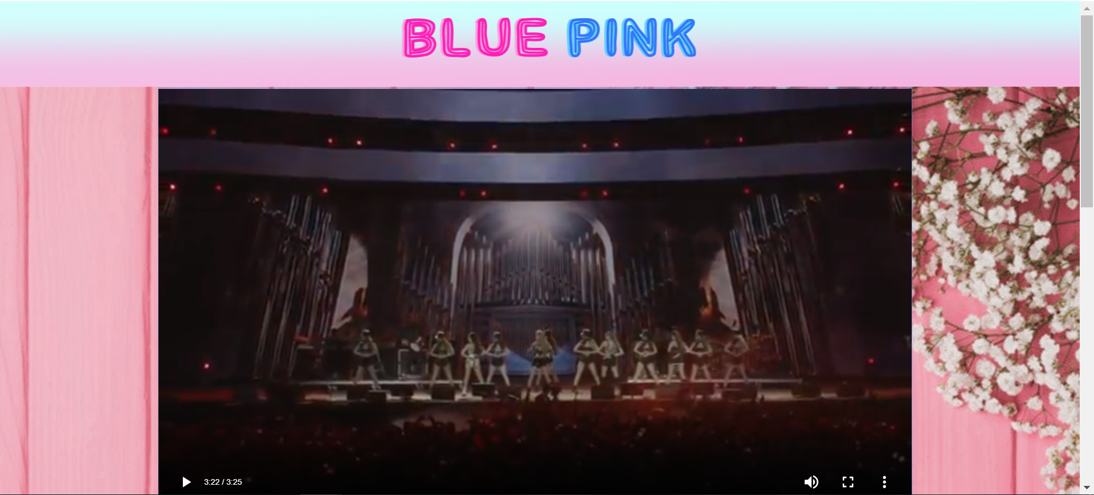

Scroll Down

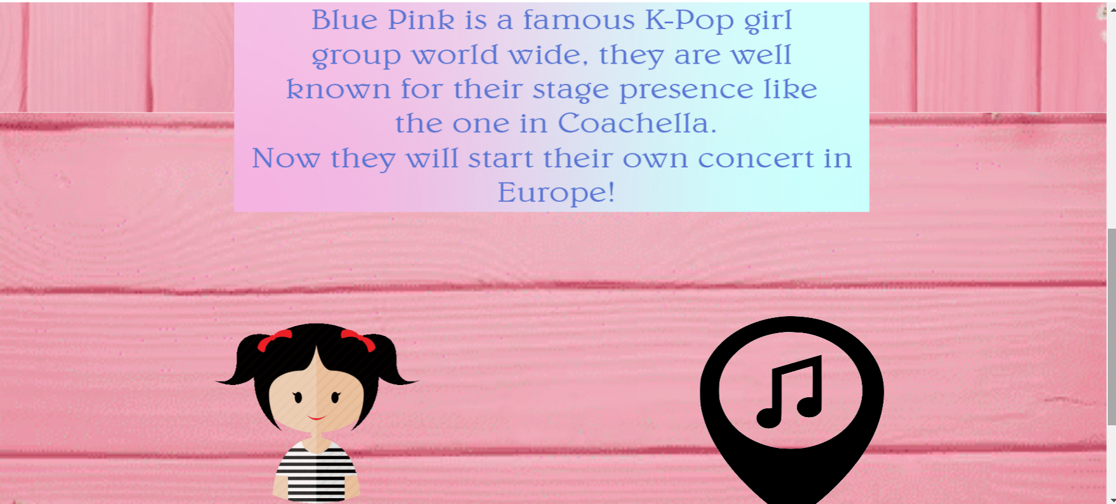

You can choose to click member button or concert Information

If you click member button

*Member Page*

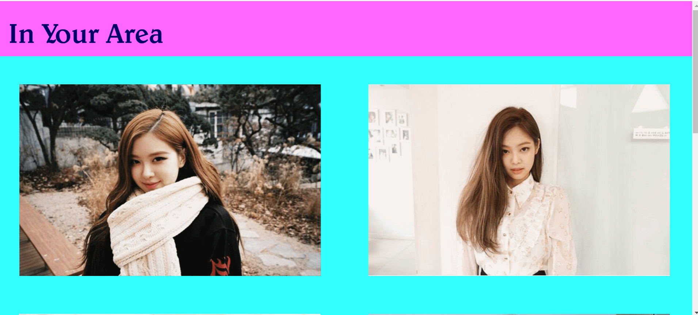

Scroll Down

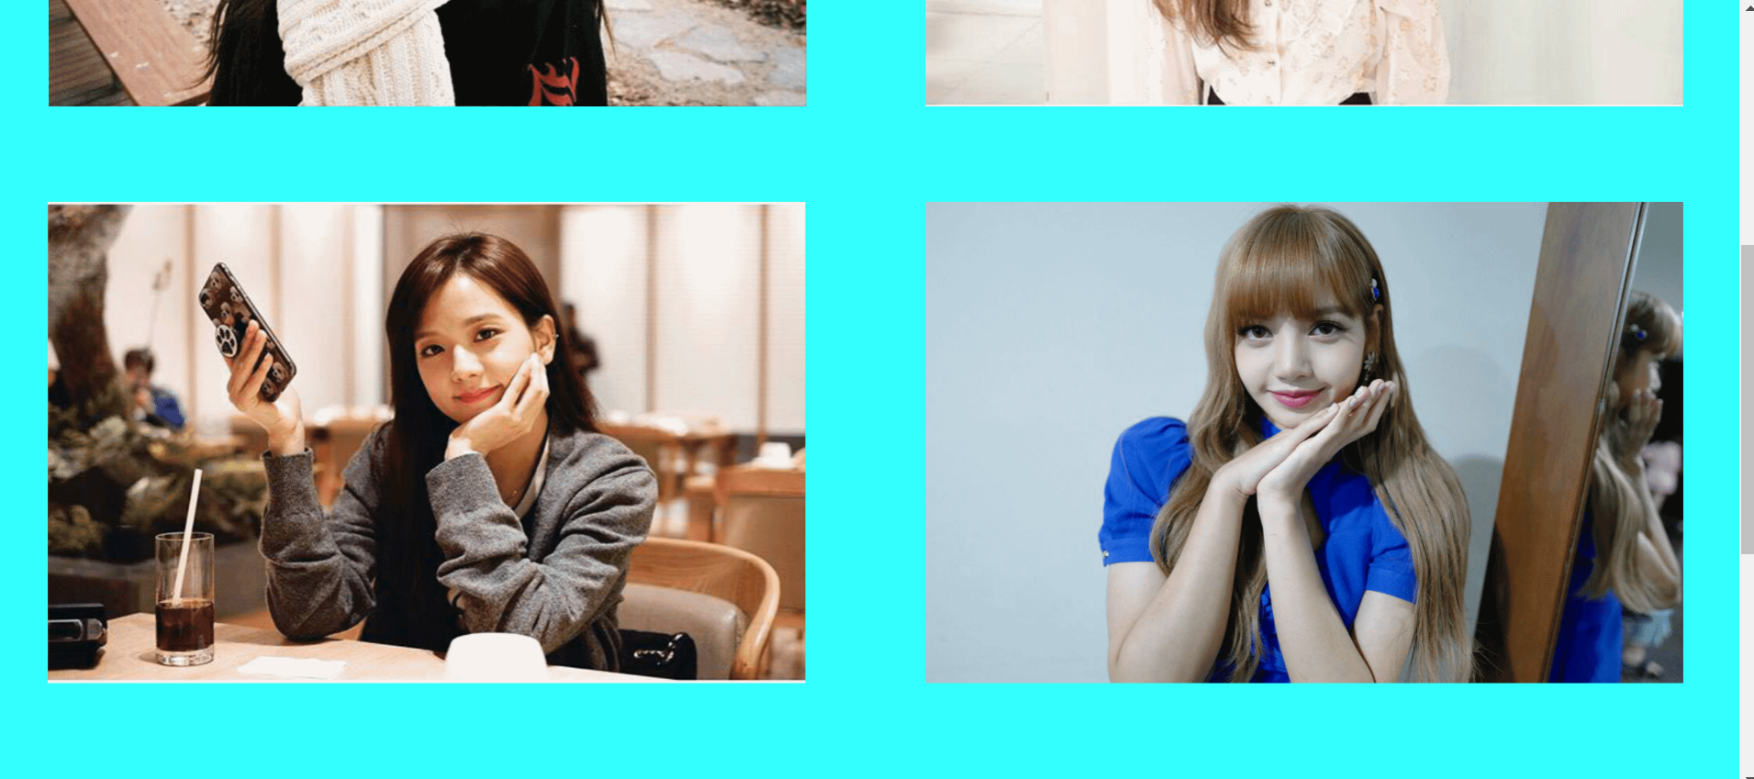

Scroll Down

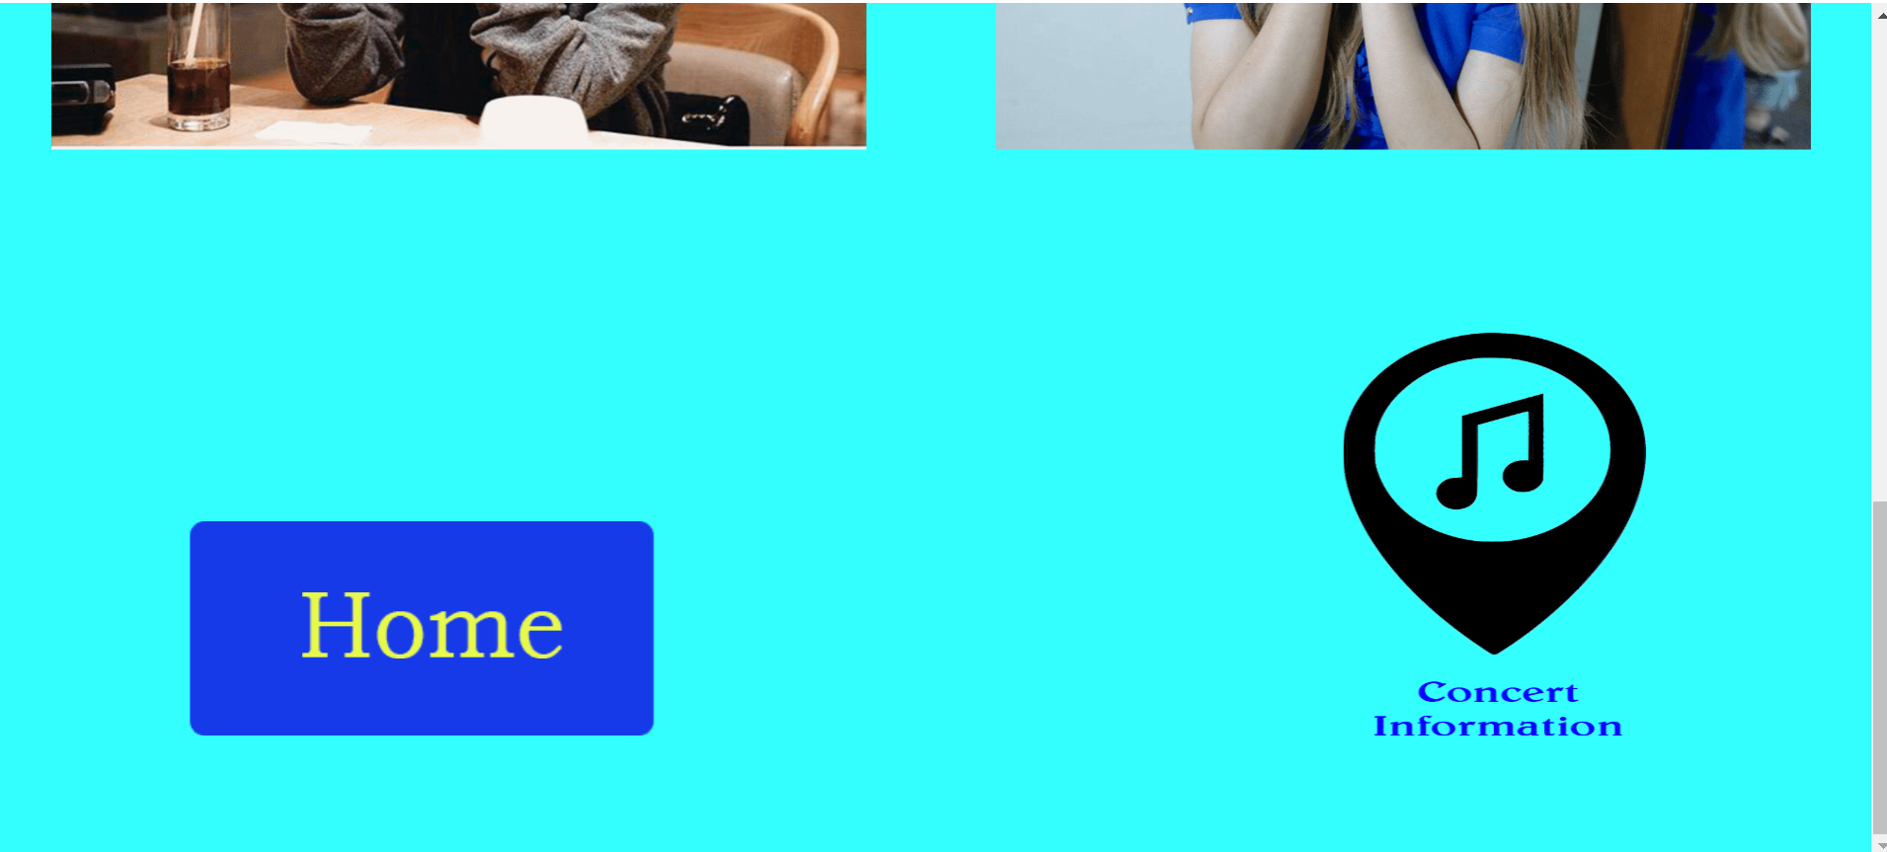

You can choose Home or Concert Information

If you choose Concert Information

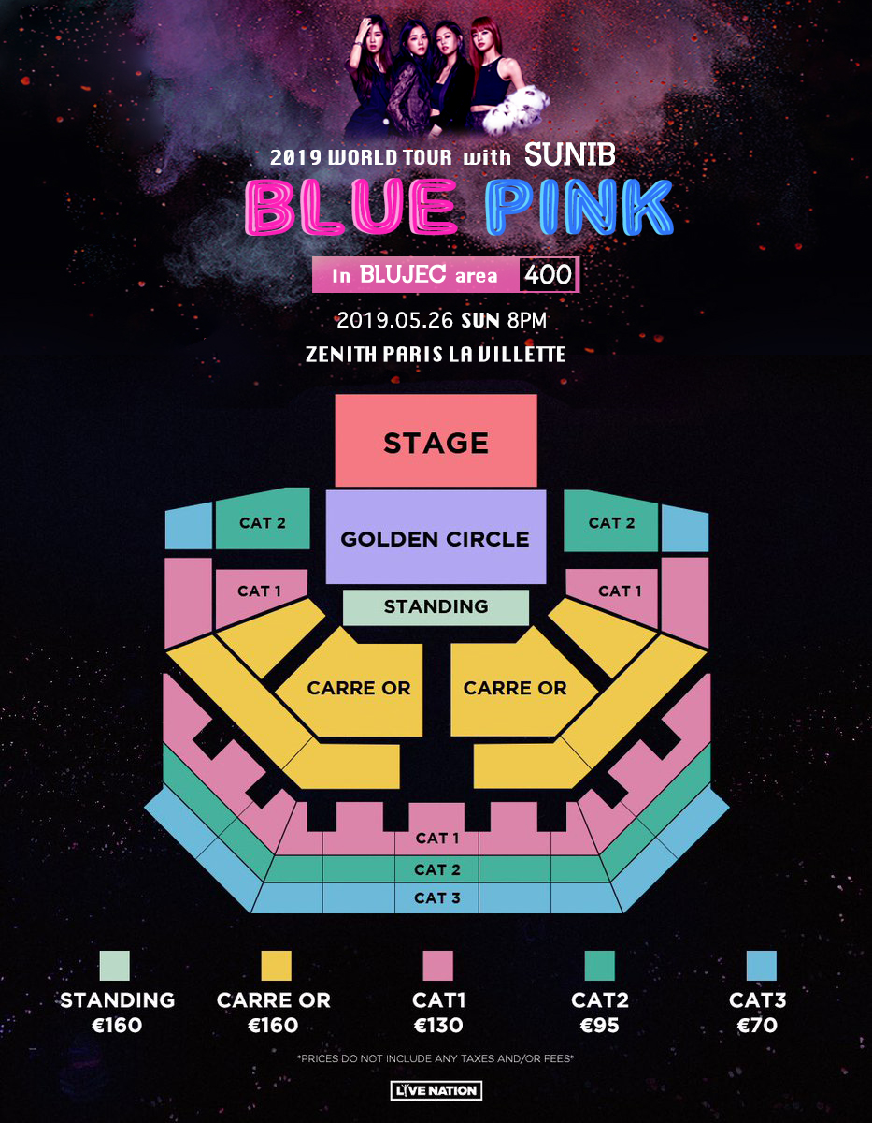

*Concert Page*

Scroll Down To Buy Tickets

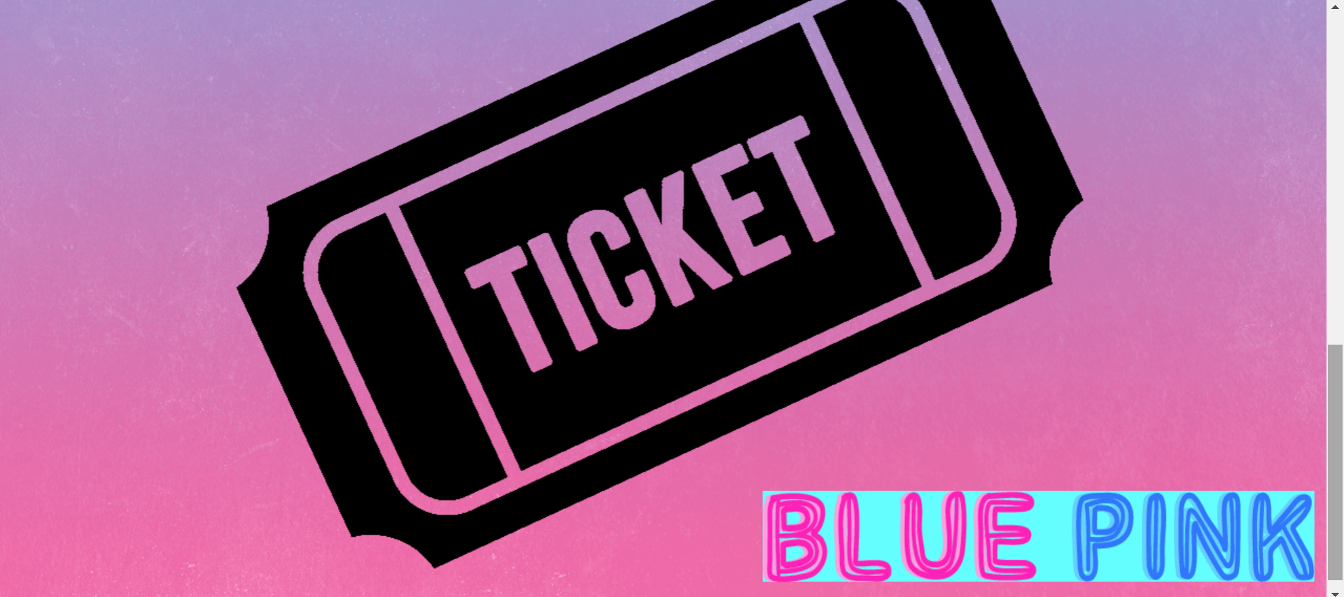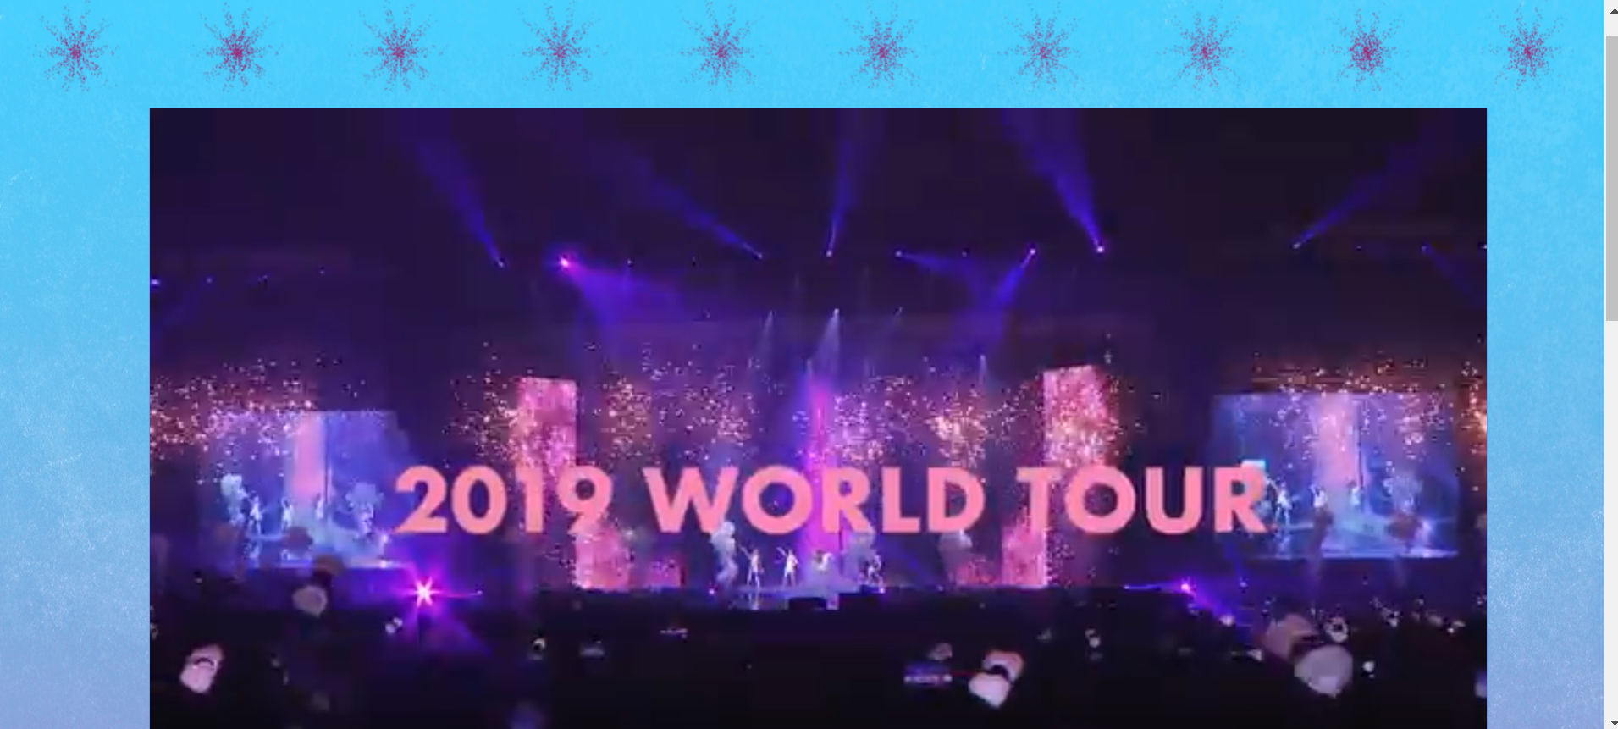

If you click the ticket button it will redirect you to the official website (to buy ticket for the concert in Paris)

**Additional Information:**

In the main page we put movie clip in the picture (when you scroll down) (mc_1 layer), Sound as the background music (BGM layer), camera at the beginning(zoom out from the members picture to the whole page)

In the member page we use 2 shape tween (from shape to text for “In your area”, from text to shape(photos) for the members pictures)

In the concert information page there are 2 more movie clip (firework and the blue pink logo),hyperlink in the ticker symbol

(+) we use adobe animate cc 2019

**Source:**

Photos: https://www.instagram.com/blackpinkofficial/

Photos: https://picsart.com/i/sticker-lisa-jisoo-jennie-rose-blackpink-blackpinklisa-246565605001212

Lisa’s Photo: https://www.instagram.com/lalalalisa_m/

Concert schedule: http://www.ygfamily.com/artist/Concert_BLACKPINK.asp?LANGDIV=K&ATYPE=2&ARTIDX=70

Seat plan: https://pbs.twimg.com/media/DyoKmtUVAAEfo6S.jpg

Video:

Coachella live: https://www.youtube.com/watch?v=SDfUm5fWF5Y

promotion:https://www.youtube.com/watch?v=9r4OkFXMOQM

Song (Forever Young): https://www.youtube.com/watch?v=s_7yNDzG7OI